**``Exercise 1: Configuring a Basic Spring Application**

**Scenario:**

Your company is developing a web application for managing a library. You need to use the Spring Framework to handle the backend operations.

**Steps:**

1. **Set Up a Spring Project:**
   * Create a Maven project named **LibraryManagement**.
   * Add Spring Core dependencies in the **pom.xml** file.
2. **Configure the Application Context:**
   * Create an XML configuration file named **applicationContext.xml** in the **src/main/resources** directory.
   * Define beans for **BookService** and **BookRepository** in the XML file.
3. **Define Service and Repository Classes:**
   * Create a package **com.library.service** and add a class **BookService**.
   * Create a package **com.library.repository** and add a class **BookRepository**.
4. **Run the Application:**
   * Create a main class to load the Spring context and test the configuration.

POM.xml:

<project xmlns="http://maven.apache.org/POM/4.0.0" xmlns:xsi="http://www.w3.org/2001/XMLSchema-instance" xsi:schemaLocation="http://maven.apache.org/POM/4.0.0 https://maven.apache.org/xsd/maven-4.0.0.xsd">

<modelVersion>4.0.0</modelVersion>

<groupId>com.library</groupId>

<artifactId>LibraryManagement</artifactId>

<version>0.0.1-SNAPSHOT</version>

<dependencies>

<dependency>

<groupId>org.springframework</groupId>

<artifactId>spring-context</artifactId>

<version>5.3.36</version>

</dependency>

<dependency>

<groupId>org.springframework</groupId>

<artifactId>spring-aspects</artifactId>

<version>5.3.36</version>

</dependency>

<dependency>

<groupId>org.springframework</groupId>

<artifactId>spring-context</artifactId>

<version>5.3.32</version>

</dependency>

<dependency>

<groupId>org.springframework</groupId>

<artifactId>spring-aop</artifactId>

<version>5.3.32</version>

</dependency>

<dependency>

<groupId>org.springframework</groupId>

<artifactId>spring-webmvc</artifactId>

<version>5.3.32</version>

</dependency>

<dependency>

<groupId>org.aspectj</groupId>

<artifactId>aspectjweaver</artifactId>

<version>1.9.19</version>

</dependency>

</dependencies>

<build>

<plugins>

<plugin>

<groupId>org.apache.maven.plugins</groupId>

<artifactId>maven-compiler-plugin</artifactId>

<version>3.8.1</version>

<configuration>

<source>1.8</source>

<target>1.8</target>

</configuration>

</plugin>

</plugins>

</build>

</project>

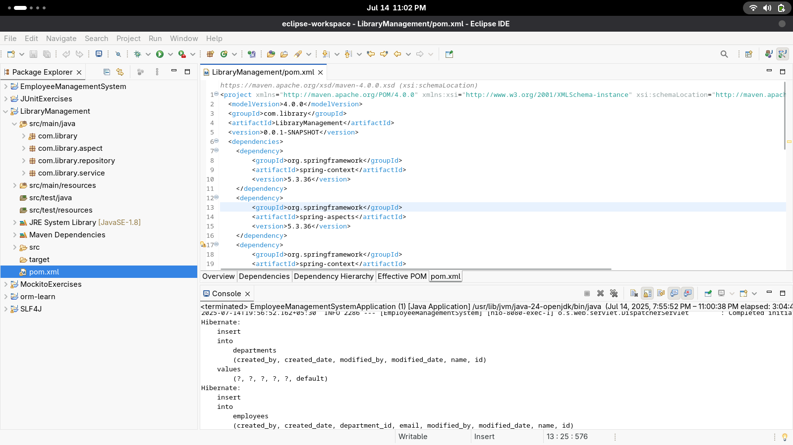

applicationcontext.xml

<?xml version="1.0" encoding="UTF-8"?>

<beans xmlns="http://www.springframework.org/schema/beans"

xmlns:xsi="http://www.w3.org/2001/XMLSchema-instance"

xmlns:context="http://www.springframework.org/schema/context"

xmlns:aop="http://www.springframework.org/schema/aop"

xsi:schemaLocation="

http://www.springframework.org/schema/beans

http://www.springframework.org/schema/beans/spring-beans.xsd

http://www.springframework.org/schema/context

http://www.springframework.org/schema/context/spring-context.xsd

http://www.springframework.org/schema/aop

http://www.springframework.org/schema/aop/spring-aop.xsd">

<aop:aspectj-autoproxy/>

<context:component-scan base-package="com.library" />

<bean id="bookRepository" class="com.library.repository.BookRepository" />

<bean id="bookService" class="com.library.service.BookService">

<constructor-arg ref="bookRepository"/>

<property name="bookRepository" ref="bookRepository" />

</bean>

